



**Project Title**

**STREAMLINING TICKET ­­­­ASSIGNMENT FOR EFFICIENT**

**SUPPORT OPERATIONS­­­­­­­­­­**

**Team Id:** NM2025TMID19503

**Team Members: 4**

## Team Leader: M GOKUL RAJ

## Team Member 1 : GIRUBAHARAN S

## Team Member 2 :J VISHAL

## TeamMember3:JOICEMAYER K

**Problem Statement:**

Support operations face inefficiencies due to manual and inconsistent ticket assignment processes. This results in delays, uneven workload distribution among agents, and longer resolution times. Without a standardized system, tickets are often assigned without considering agent expertise, availability, or priority levels, leading to suboptimal customer experiences and reduced team productivity.

There is a need for a streamlined, intelligent ticket assignment mechanism that ensures tickets are automatically and appropriately routed based on defined criteria such as agent skill sets, workload capacity, ticket priority, and issue type. This will improve response times, balance workloads, and enhance overall support efficiency and customer satisfaction.

## Objective:

## To implement an intelligent and automated ticket assignment system that ensures support tickets are routed to the most suitable agents based on predefined criteria such as expertise, availability, ticket priority, and workload. This initiative aims to reduce response and resolution times, evenly distribute workloads, improve agent productivity, and enhance overall customer satisfaction

**Skills:**

To effectively streamline ticket assignment for efficient support operations, a combination of **technical**, **analytical**, and **operational** skills is essential. Here's a breakdown of the key skills needed:

## 

## TASK INITIATION

# MILESTONE -1 USERS

**ACTIVITY 1:create Users**

**PURPOSE:**

User creation helps set up profiles for support agents with their skills, availability, and roles. This makes it easier to quickly assign tickets to the right person, improving support speed and customer satisfaction.

**USES**

User creation saves key details about each support agent, like their skills and availability. This helps the system quickly assign tickets to the right agent, making support faster and more efficient

.

**STEPS:**

1.Open service now.

2.Click on All >> search for user

3. Select Users under system security

4.Click on new

5. Fill the following details to create a new user

6.Click on submit

Create one more user

7.Create another user with the following details

8.Click on submit

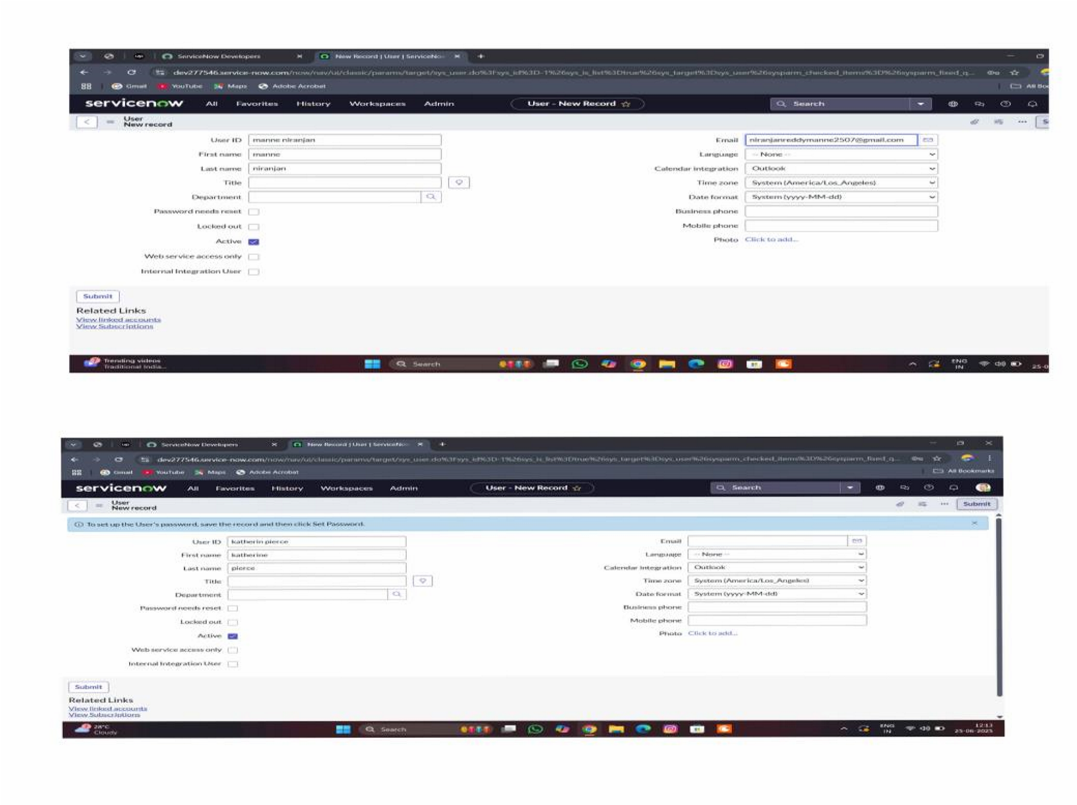

# MILESTONE -2 GROUPS

**ACTIVITY 1: create Groups**

**PURPOSE:**

Group creation helps organize support agents into teams based on their skills, departments, or ticket types. This makes it easier to assign tickets to the right team, improving ticket handling speed and ensuring the right experts work on the right issues.

**USES:**

Group creation helps organize support agents into teams based on skills or departments. This makes it easier to quickly assign tickets to the right team, improving support speed, workload balance, and overall efficiency.

**STEPS:**

1.Open service now.

2.Click on All >> search for groups

3.Select groups under system security

4.Click on new

5.Fill the following details to create a new group

6.click on submit

Create one more Group

7.Create another group with the following details

8.Click on submit

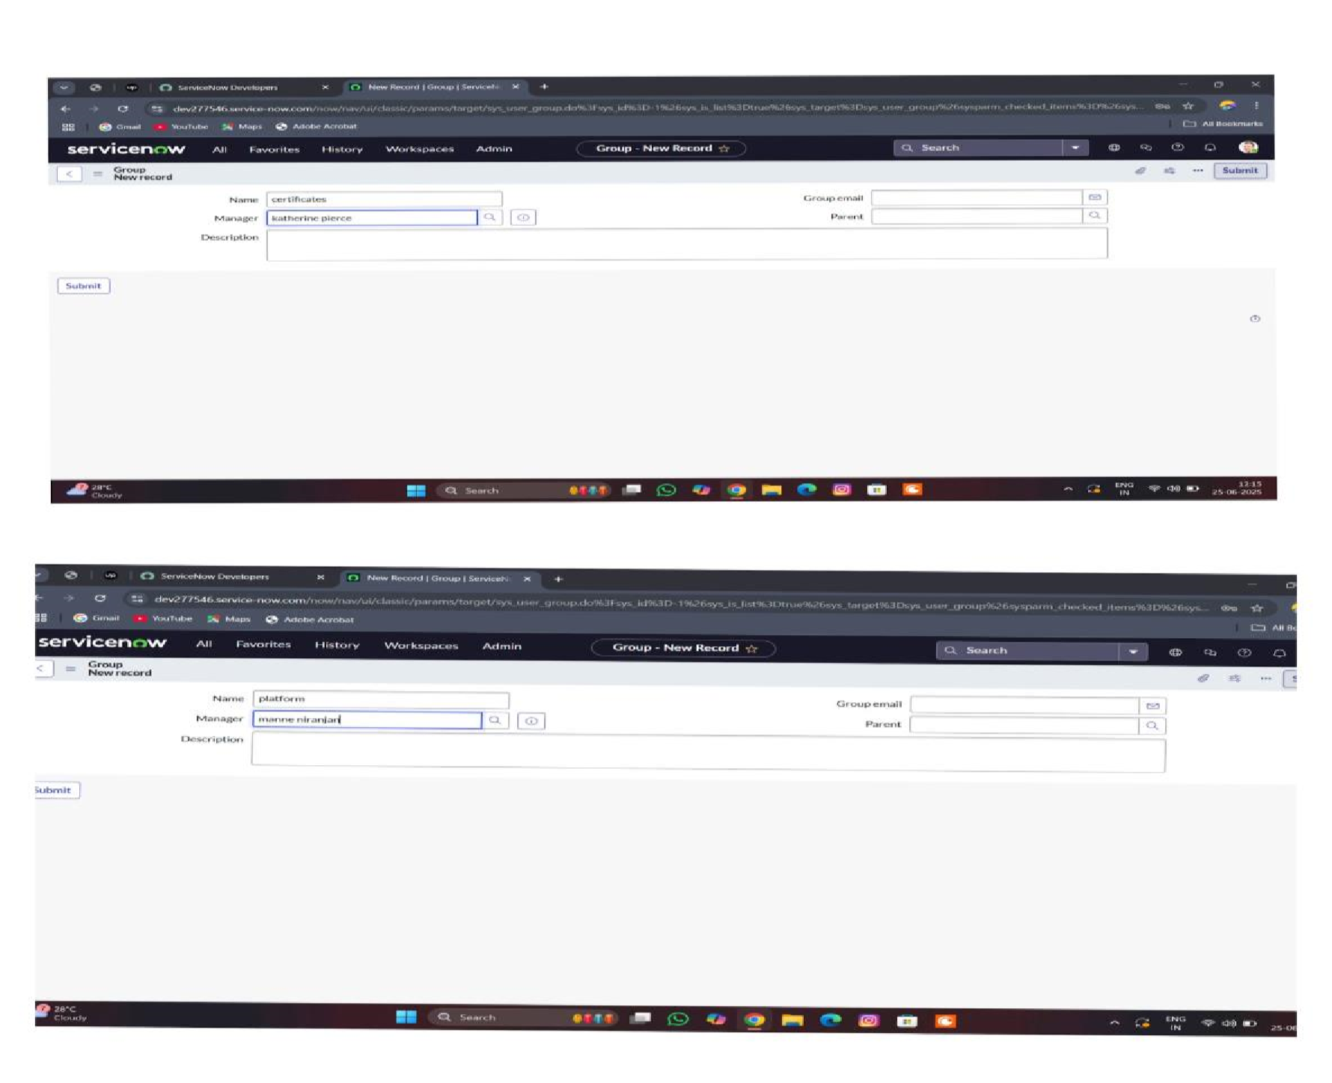

# MILESTONE -3 ROLES

**ACTIVITY 1: Create Roles**

**PURPOSE:**

Roles creation defines what each user can do in the system, such as managing tickets, handling specific tasks, or overseeing teams. It helps control access, organize responsibilities, and ensure the right people have the right permissions to keep the support process smooth and secure.

**USES:**

Roles creation helps assign specific permissions and responsibilities to each user. It ensures that agents, team leads, and managers can only access the features they need, making the ticket assignment process organized, secure, and efficient.

**STEPS:**

1.Open service now

2.Click on All >> search for roles

3.Select roles under system security

4.Click on new

5.Fill the following details to create a new role

6.Click on submit

Create one more role

7.Create another role with the following details

8.click on submit

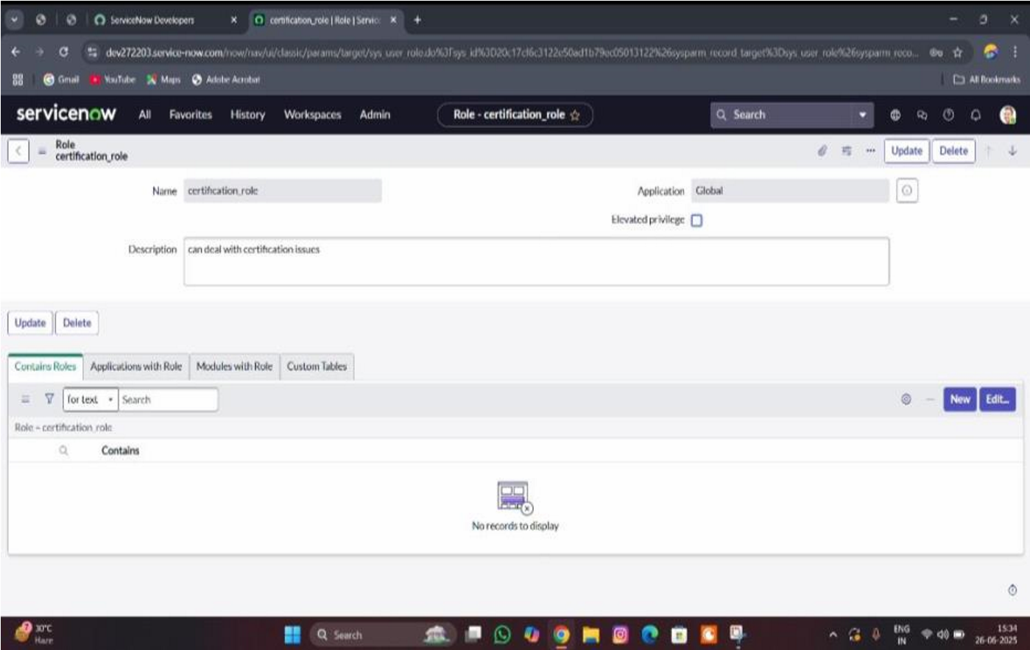

# MILESTONE -4 TABLE

**ACTIVITY-1 Creating Table**

**PURPOSE:**

Table creation is used to store, organize, and display important data like user details, ticket information, groups, and roles in a clear and structured way. This helps the system easily manage and track tickets, making the assignment process faster, more accurate, and easier to control.

**USES:**

Table creation helps store and organize data like users, tickets, groups, and roles. It makes it easy to manage, track, and quickly assign tickets to the right agents or teams.

**STEPS:**

**1.**Open service now.

2.Click on All >> search for tables

3.Select tables under system definition

4.Click on new

5.Fill the following details to create a new table

Label : Operations related

Check the boxes Create module & Create mobile module

6.Under new menu name : Operations related

7.Under table columns give the columns

8.Click on submit

Create choices for the issue filed by using form design

Choices are

*unable to login to platform

* 404 error

*regarding certificates

*regarding user expired

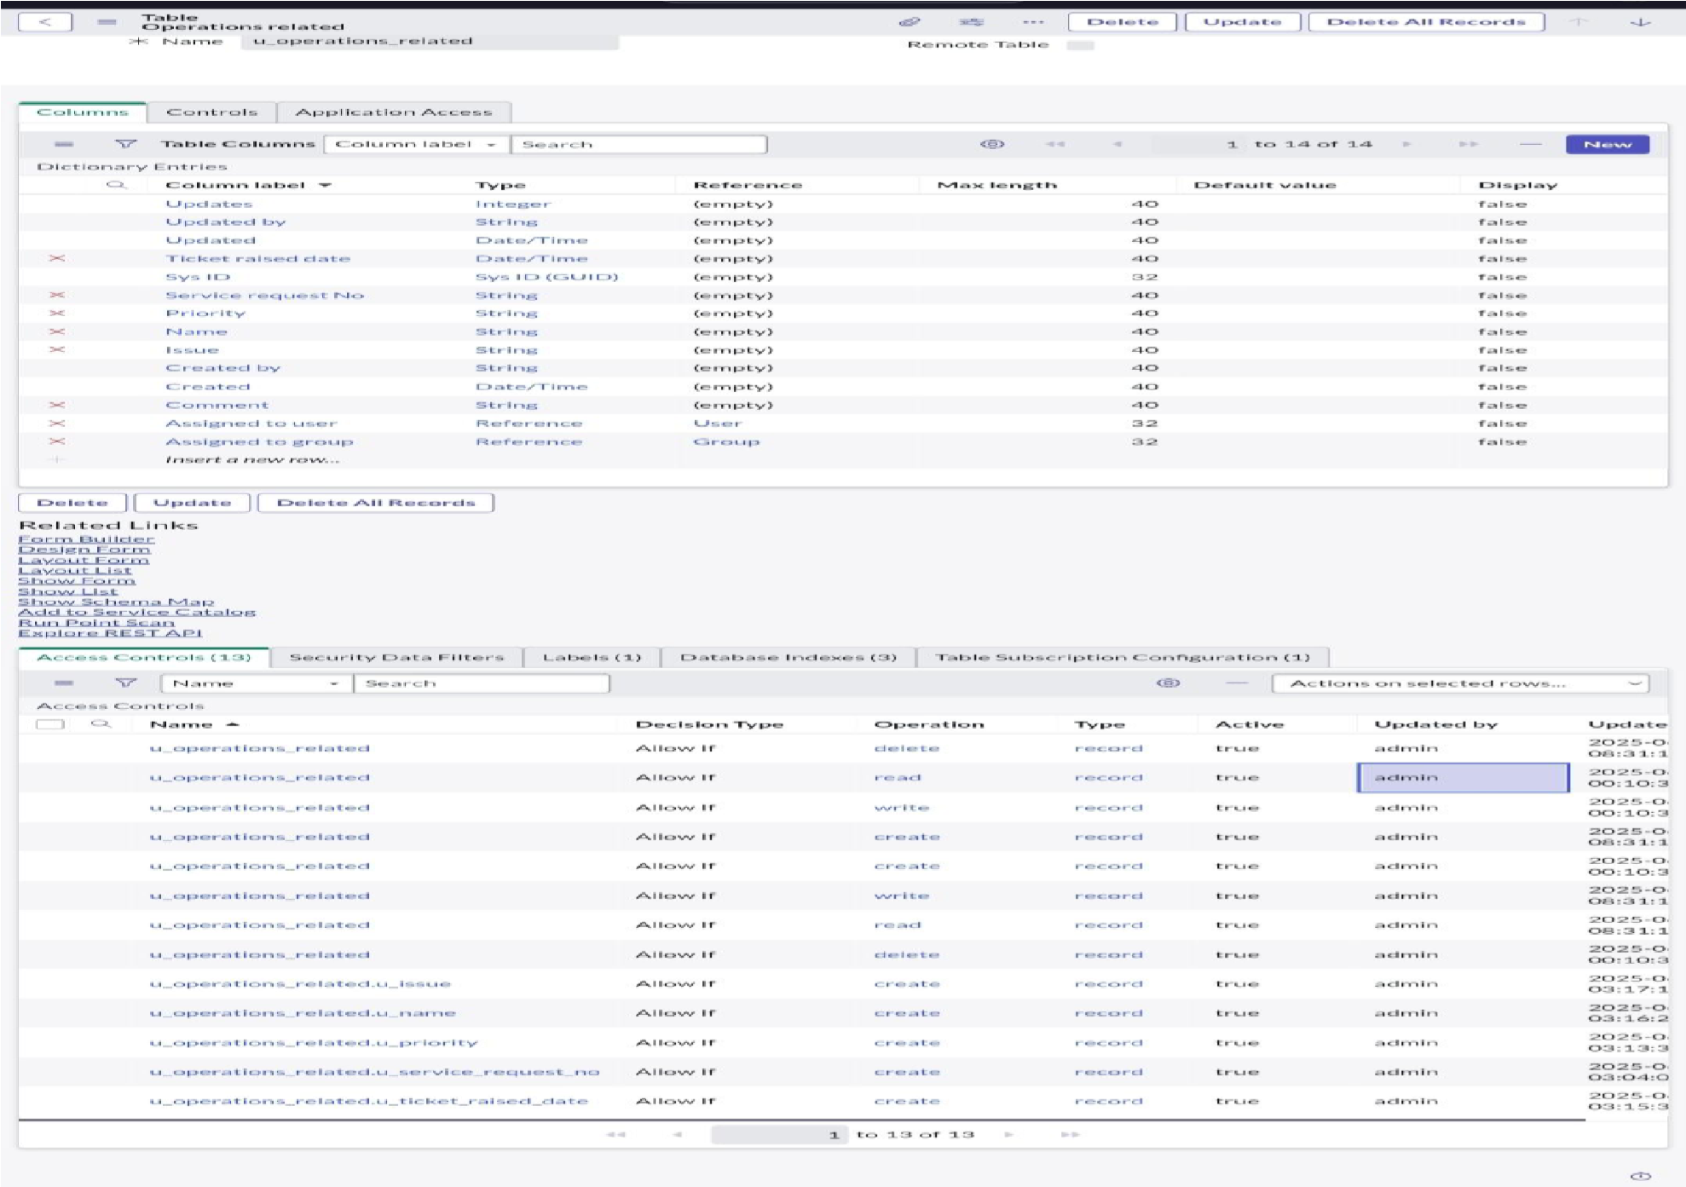

# MILESTONE -5 ASSIGN ROLES & USERS TO GROUP

**ACTIVITY-1 Assign roles & users to certificate group**

**PURPOSE:**

Assigning roles and users to a certificate group helps make sure the right people handle the right tickets. It ensures tickets go to qualified agents quickly and s

**USES:**

It helps the system automatically send specific tickets to the right certified agents or teams, making ticket assignment faster, more accurate, and handled by qualified people.

**STEPS:**

1.Open service now.

2.Click on All >> search for tables

3.Select tables under system definition

4.Select the certificates group

5.Under group members

6.Click on edit

7.Select Katherine Pierce and save

8.Click on roles

9.Select Certification_role and save

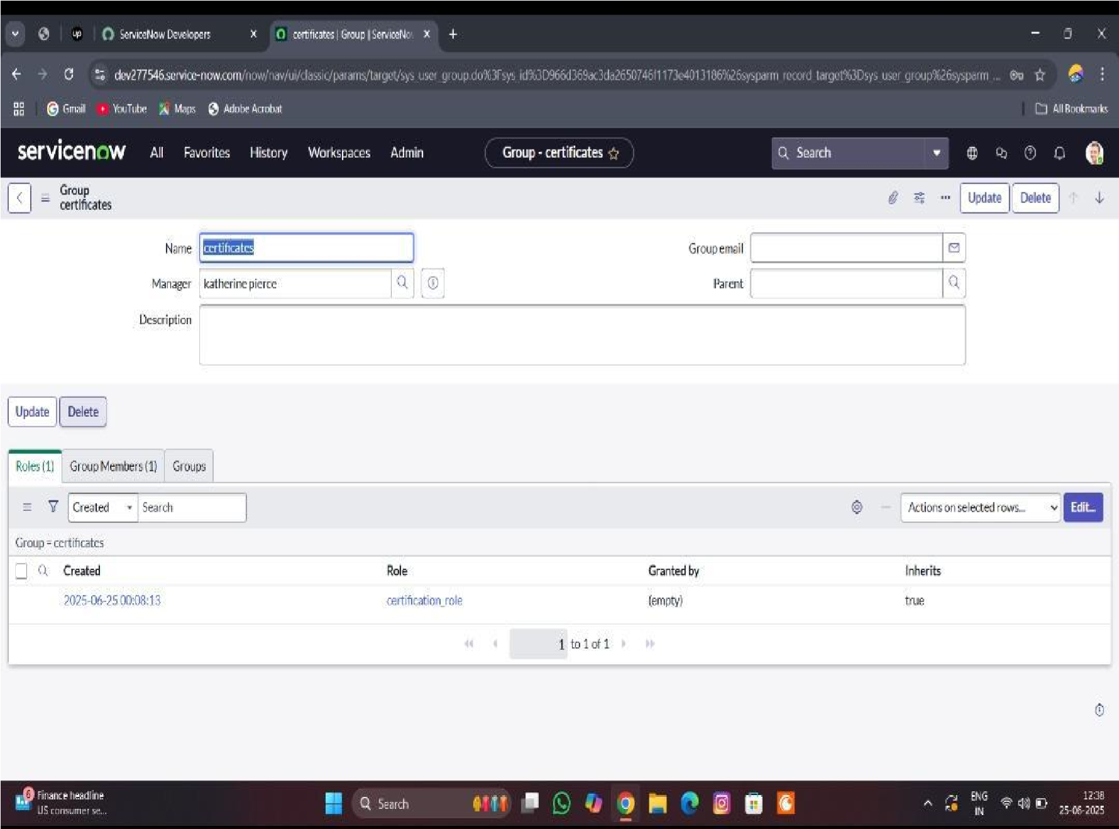

**ACTIVITY -2 Assign roles & users to platform group**

**PURPOSE:**

Assigning roles and users to a platform group helps organize agents based on the platforms or tools they support. This ensures tickets related to specific platforms are quickly assigned to the right experts, improving accuracy

**USES:**

It helps the system automatically send platform-specific tickets to the right agents who are trained for that platform, making ticket assignment faster, more accurate, and efficient.

**STEPS:**

1.Open service now.

2.Click on All >> search for tables

3.Select tables under system definition

4.Select the platform group

5.Under group members

6.Click on edit

7.Select Manne Niranjan and save

8.Click on role

9.give platform role and save

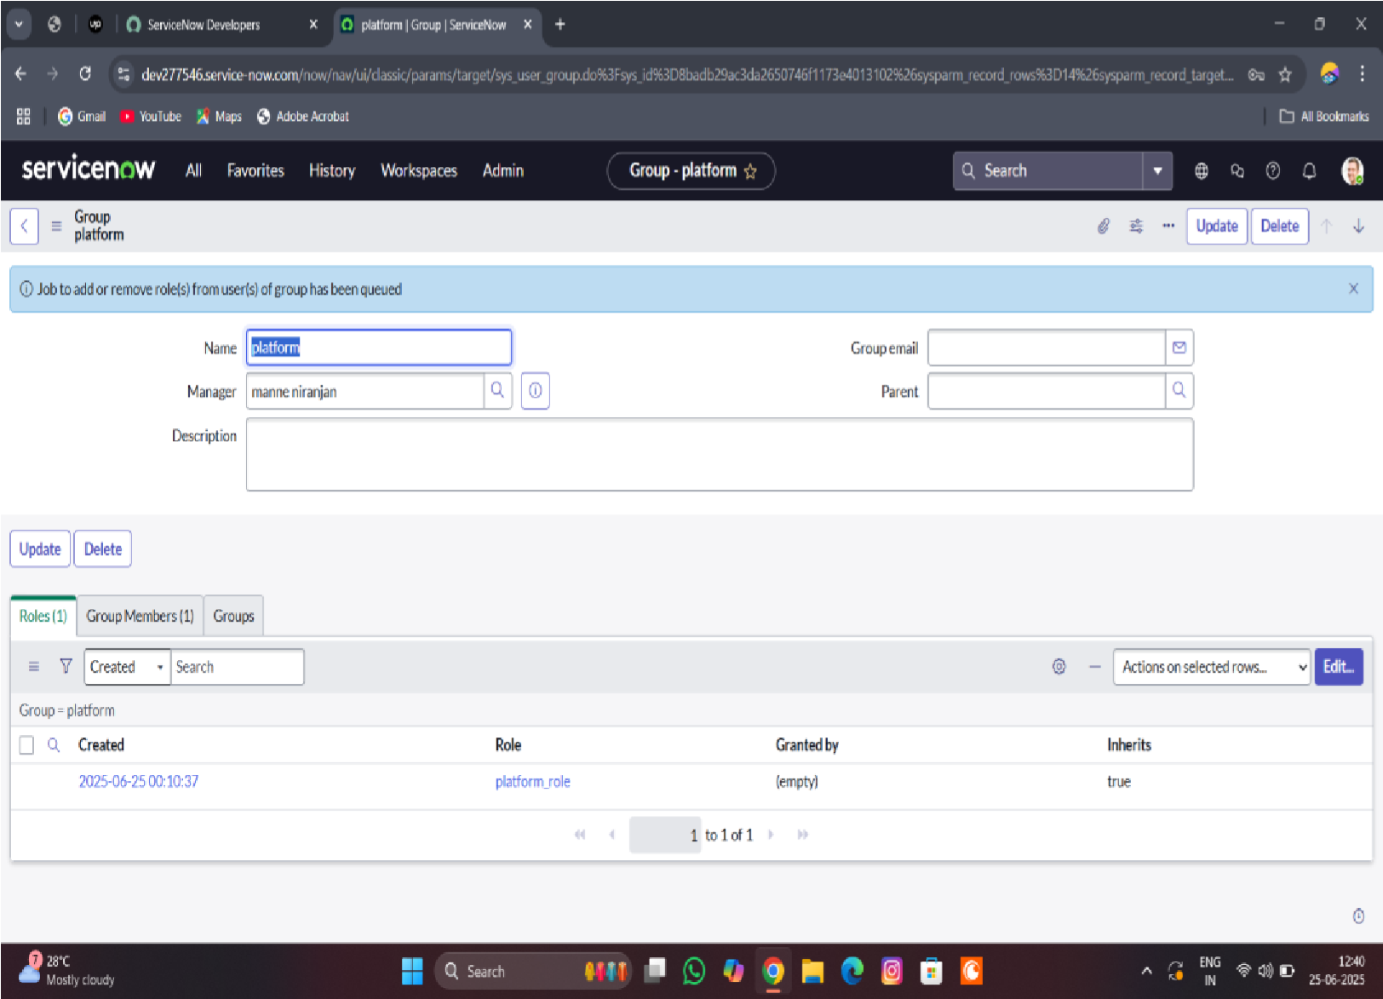

# MILESTONE-6 ASSIGN ROLE TO TABLE

**ACTIVITY-1 Assign role to table**

**PURPOSE:**

Assigning roles to a table helps control who can view, edit, or manage the information in that table. It ensures that only the right users with proper permissions can access or update ticket, user, or group data, keeping the system organized, secure, and efficient.

**USES:**

It controls who can see or update the table data, making sure only the right people can manage tickets, users, or groups. This keeps the ticket assignment process safe, organized, and efficient.

**STEPS:**

1.Open service now.

2.Click on All >> search for tables

3.Select operations related table

4.Click on the Application Access

5.Click on u_operations_related read operation

6.Click on the profile on top right side

7.Click on elevate role

8.Click on security admin and click on update

9.Under Requires role

10.Double click on insert a new row

11.Give platform role

12.And add certificate role

13.Click on update

14. Click on u_operations_related write operation

15.Under Requires role

16.Double click on insert a new row

17.Give platform role

18.And add certificate role

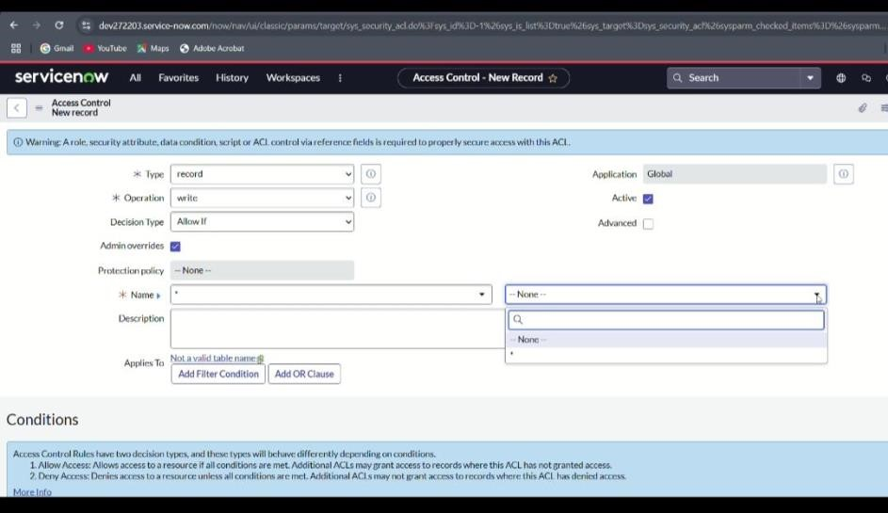

# MILESTONE-7 CREATE ACL

**ACTIVITY-1 Create ACL**

**PURPOSE:**

Creating an ACL (Access Control List) helps set rules about who can view, create, edit, or delete specific data. This keeps the ticket assignment process secure by making sure only authorized users can access or change important information.

**USES:**

Creating an ACL helps control user access to tickets, tables, and other system data. It makes sure only the right people can view or update information, keeping the ticket assignment process secure and well-managed.

**STEPS:**

1.Open service now.

2.Click on All >> search for ACL

3.Select Access Control(ACL) under system security

4.Click on new

5.Fill the following details to create a new ACL

6.Scroll down under requires role

7.Double click on insert a new row

8.Give admin role

9.Click on submit

10.Similarly create 4 acl for the following fields

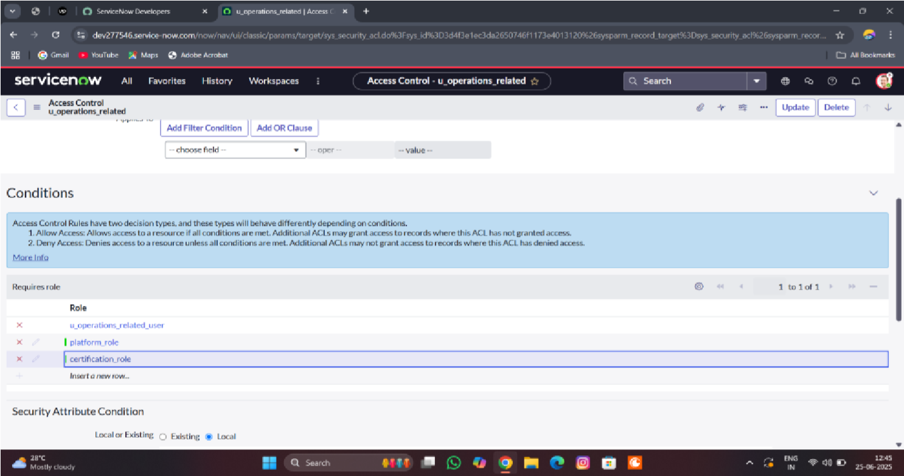

# MILESTONE -8 FLOW

**ACTIVITY-1 Create a Flow to Assign operations ticket to group**

**PURPOSE:**

Purpose of Creating a Flow to Assign Operations Ticket to Group: The purpose is to automate the process of directing operations-related tickets to the right support group.

**USES:**

It automatically routes operations tickets to the correct group, speeding up ticket handling and improving support efficiency.

**STEPS:**

1.Open service now.

2.Click on All >> search for Flow Designer

3.Click on Flow Designer under Process Automation.

4.After opening Flow Designer Click on new and select Flow.

5.Under Flow properties Give Flow Name as “ Regarding Certificate”.

6.Application should be Global.

7.Select Run user as “ System user ” from that choice.

8.Click on Submit.

1.Click on Add a trigger

2.Select the trigger in that Search for “create or update a record” and select that.

3.Give the table name as “ Operations related ”.

4.Give the Condition as

Field : issue

Operator : is

Value : Regrading Certificates 5.After that click on Done

6.Now under Actions.

7.Click on Add an action.

8.Select action in that search for “ Update Record ”.

9.In Record field drag the fields from the data navigation from left side

10.Table will be auto assigned after that

11.Give the field as “ Assigned to group ” 12.Give value as “ Certificates ”

13.Click on Done.

14.Click on Save to save the Flow.

15.Click on Activate.

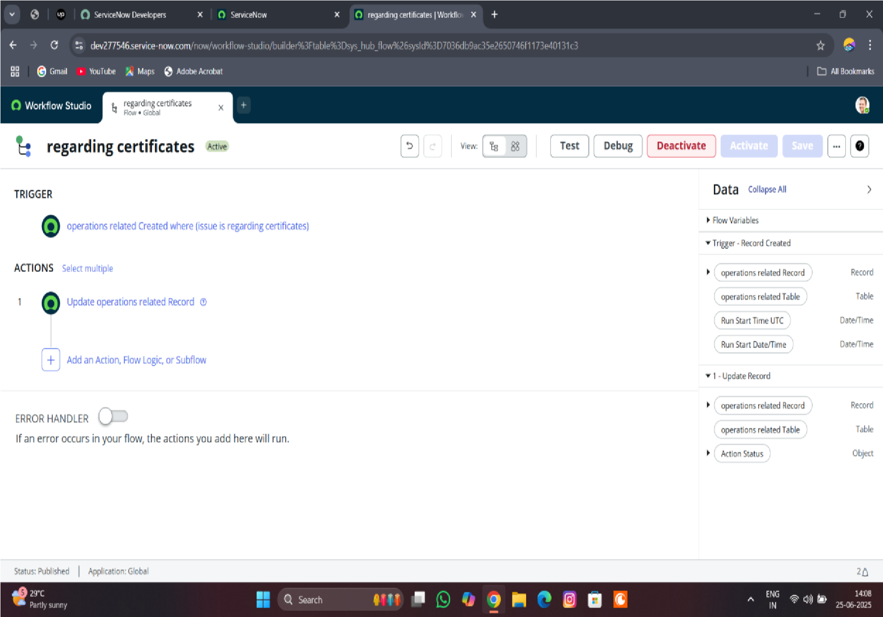

**ACTIVITY-2 Create a Flow to Assign operations ticket to Platform**

**PURPOSE:**

To automatically assign operations tickets to the right platform experts, ensuring faster and accurate support.

**USES:**

It routes operations tickets to the correct platform specialists automatically, improving response time and support accurate

**STEPS:**

1.Open service now.

2.Click on All >> search for Flow Designer

3.Click on Flow Designer under Process Automation.

4.After opening Flow Designer Click on new and select Flow.

5.Under Flow properties Give Flow Name as “ Regarding Platform ”.

6.Application should be Global.

7.Select Run user as “ System user ” from that choice.

8.Click on Submit.

1.Click on Add a trigger

2.Select the trigger in that Search for “create or update a record” and select that.

3.Give the table name as “ Operations related ”.

4.Give the Condition as

Field : issue

Operator : is

Value : Unable to login to platform

5.Click on New Criteria

Field : issue

Operator : is

Value : 404 Error

6.Click on New Criteria

Field : issue

Operator : is

Value : Regrading User expired

7.After that click on Done.

8.Now under Actions.

9.Click on Add an action.

10.Select action in that search for “ Update Record ”.

11. In Record field drag the fields from the data navigation from left side

12.Table will be auto assigned after that

13.Give the field as “ Assigned to group ”. 14.Give value as “ Platform ”

15.Click on Done.

16.Click on Save to save the Flow.

17.Click on Activate.

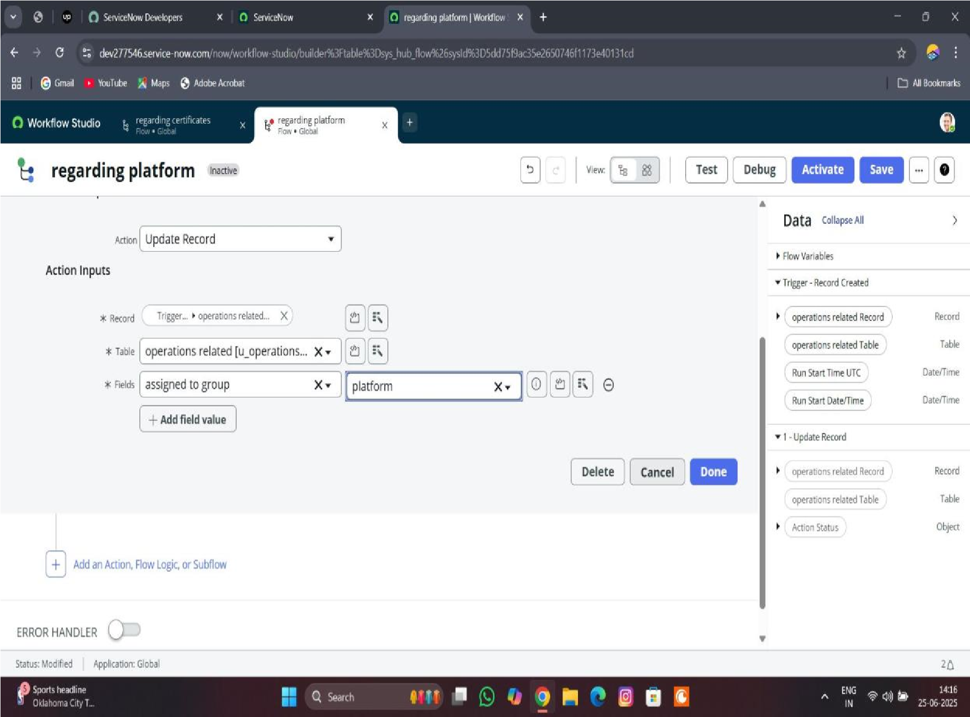

|  |  |  |  |
| --- | --- | --- | --- |
| **Functional requirements** | **User story** | **No.of activiti es** | **Team members** |
| Users | As an admin,I want to create user profiles with details like name, skills, availability, and role,So that the system can automatically assign tickets to the right support agents quickly and accurately. | 1 | Y.dhilleeswari |
| Groups | As an admin,I want to create groups based on skills, departments, or ticket types,So that tickets can be quickly assigned to the right team for faster and more efficient support. | 1 | Y.dhilleeswari |
| Roles | As an admin,I want to create roles with specific permissions and responsibilities,So that users can access only the features and data they need to perform their tasks efficiently and securely. | 1 | U.lalitha |
| Tables | As an admin,I want to create tables to store and organize data like users, groups, roles, and tickets,So that the system can easily manage and quickly access the information needed for efficient ticket assignment. | 1 | T.susmitha |
| Assign roles & users to groups | As an admin,I want to assign specific roles and users to appropriate groups,So that tickets can be automatically routed to the right teams and handled by qualified agents quickly and efficiently. | 2 | U.lalitha |
| Assign role to table | As an admin,I want to assign specific roles to tables,So that only authorized users can view, edit, or manage the data, ensuring secure and organized ticket assignment operations. | 1 | T.susmitha |
| Create ACL | As an admin,I want to create Access Control Lists (ACLs) that define who can access or modify different parts of the system,So that ticket assignment and support data remain secure and only authorized users can make changes | 1 | S.Mounika |
| Flow | As an admin,I want to create automated workflows that guide how tickets are assigned and processed,So that tickets move smoothly to the right agents or teams without delays, improving support efficiency. | 2 | S.Mounika |

# FUNCTIONAL AND PERFORMANCE TESTING

# MILESTONE -8 FLOW

**ACTIVITY-1 Create a Flow to Assign operations ticket to group**

**PURPOSE:**

Purpose of Creating a Flow to Assign Operations Ticket to Group: The purpose is to automate the process of directing operations-related tickets to the right support group.

**USES:**

It automatically routes operations tickets to the correct group, speeding up ticket handling and improving support efficiency.

**STEPS:**

1.Open service now.

2.Click on All >> search for Flow Designer

3.Click on Flow Designer under Process Automation.

4.After opening Flow Designer Click on new and select Flow.

5.Under Flow properties Give Flow Name as “ Regarding Certificate”.

6.Application should be Global.

7.Select Run user as “ System user ” from that choice.

8.Click on Submit.

1.Click on Add a trigger

2.Select the trigger in that Search for “create or update a record” and select that.

3.Give the table name as “ Operations related ”.

4.Give the Condition as

Field : issue

Operator : is

Value : Regrading Certificates 5.After that click on Done

6.Now under Actions.

7.Click on Add an action.

8.Select action in that search for “ Update Record ”.

9.In Record field drag the fields from the data navigation from left side

10.Table will be auto assigned after that

11.Give the field as “ Assigned to group ” 12.Give value as “ Certificates ”

13.Click on Done.

14.Click on Save to save the Flow.

15.Click on Activate.

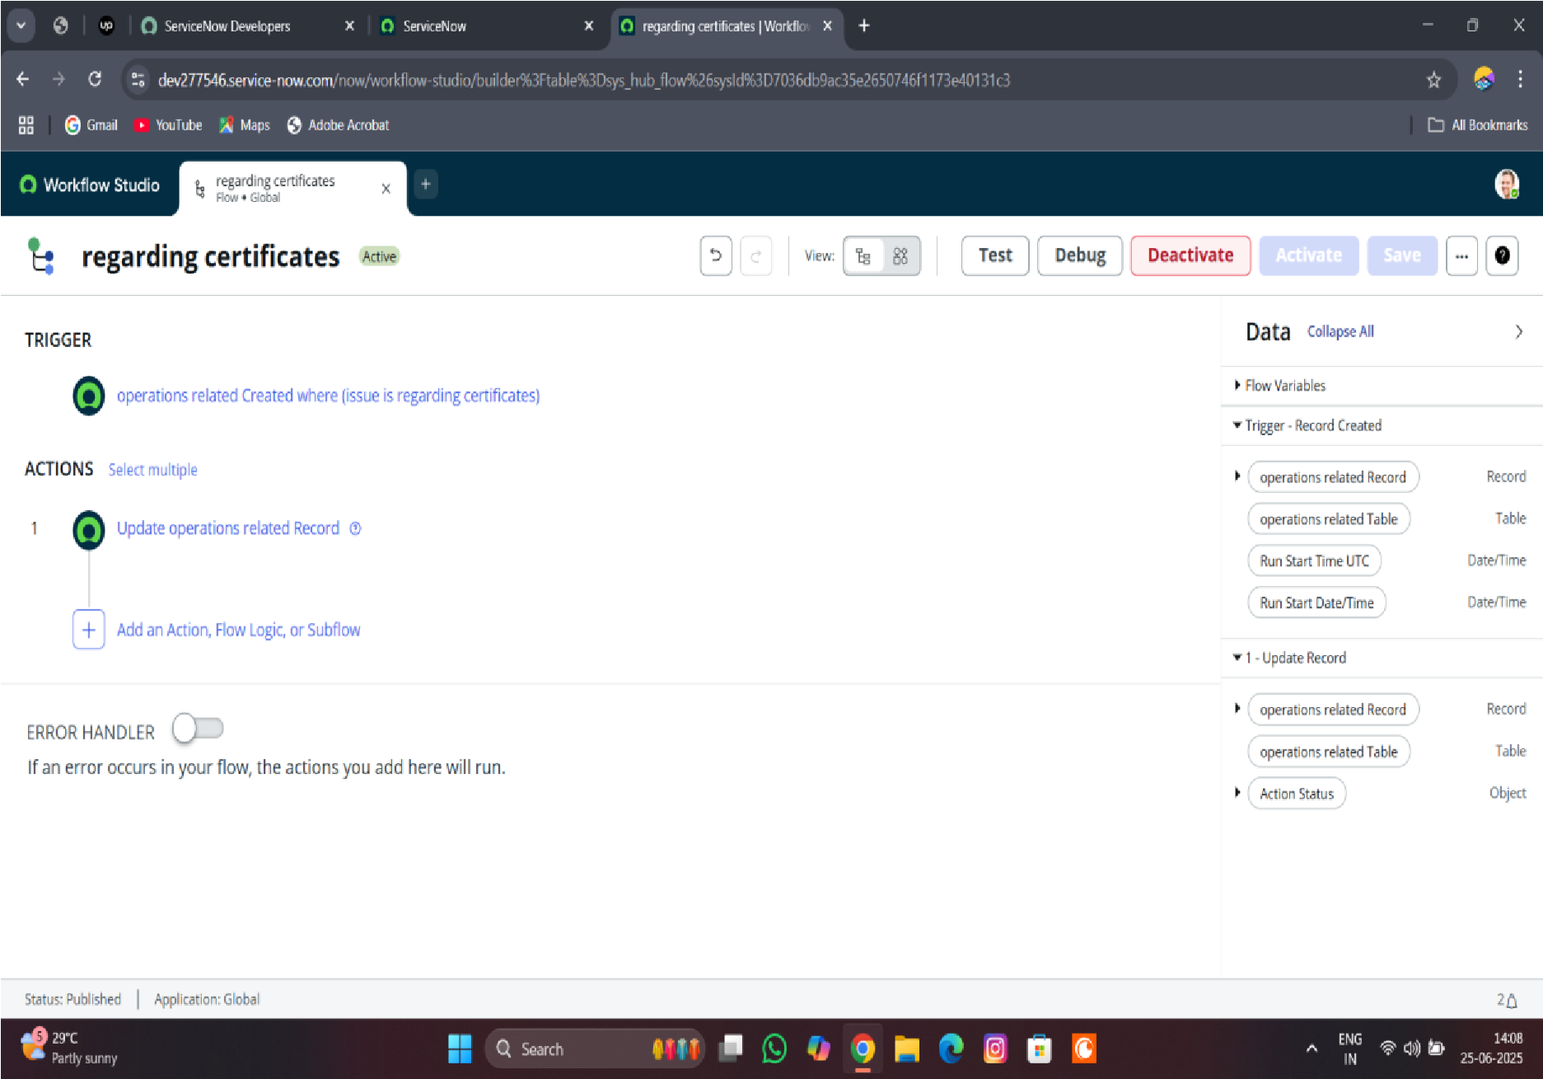

**ACTIVITY-2 Create a Flow to Assign operations ticket to Platform**

**PURPOSE:**

To automatically assign operations tickets to the right platform experts, ensuring faster and accurate support.

**USES:**

It routes operations tickets to the correct platform specialists automatically, improving response time and support accurate

**STEPS:**

1.Open service now.

2.Click on All >> search for Flow Designer

3.Click on Flow Designer under Process Automation.

4.After opening Flow Designer Click on new and select Flow.

5.Under Flow properties Give Flow Name as “ Regarding Platform ”.

6.Application should be Global.

7.Select Run user as “ System user ” from that choice.

8.Click on Submit.

1.Click on Add a trigger

2.Select the trigger in that Search for “create or update a record” and select that.

3.Give the table name as “ Operations related ”.

4.Give the Condition as

Field : issue

Operator : is

Value : Unable to login to platform

5.Click on New Criteria

Field : issue

Operator : is

Value : 404 Error

6.Click on New Criteria

Field : issue

Operator : is

Value : Regrading User expired

7.After that click on Done.

8.Now under Actions.

9.Click on Add an action.

10.Select action in that search for “ Update Record ”.

11. In Record field drag the fields from the data navigation from left side

12.Table will be auto assigned after that

13.Give the field as “ Assigned to group ”. 14.Give value as “ Platform ”

15.Click on Done.

16.Click on Save to save the Flow.

17.Click on Activate.

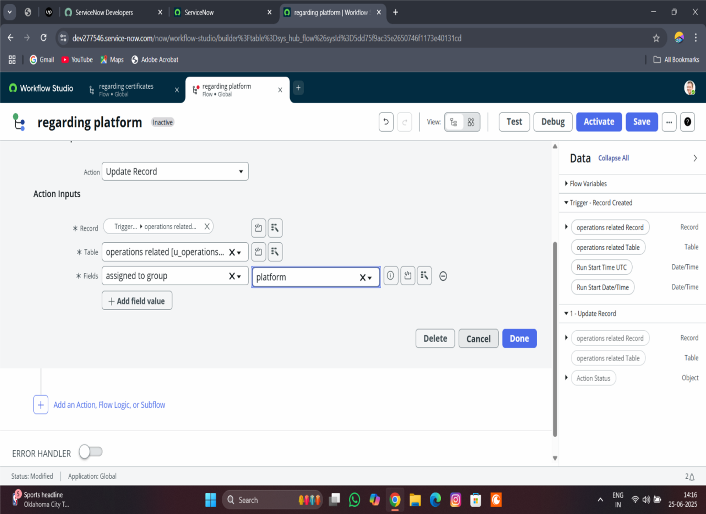

**Conclusion :**

## 

## 